**IFT 466 Advanced Computer Networks**

**Lab 8  
EIGRP – Manual Summarization**

After you complete each step, put a ‘√’ or ‘x’ in the completed box

1. Setup up the following topology on Packet Tracer

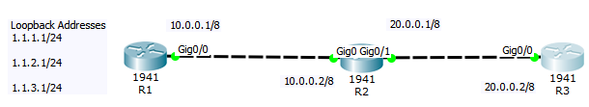



✓

1. Configure both routers with the layer 3 addressing all on appropriate interfaces as shown in the topology.



✓

1. We will now create 3 logical interfaces to simulate 3 networks on Router 1 as shown below.

✓

1. Now we have 3 subnets that start with 1.1  
     
   Now we will verify using the show ip interface brief command on R1 and you can see 3 loopback interfaces.

You can now see 3 IP addresses of 1.1 subnet and the gigabit interface network all on this router (R1)

✓

1. Graphical user interface

   Description automatically generated with medium confidenceNow we will configure EIGRP on this router (R1).

**Tip:** We will use the command network 0.0.0.0 which means advertise all networks including loopbacks

✓

6. Configure EIGRP on R2 using the same network 0.0.0.0 command.   
  
 You will see a neighbour has already being discovered - R1

Neighbor discovery happens by the DUAL algorithm   
(DUAL discovers neighbor & ensures loop free classless network & picks the best route for forwarding the packet)

✓

1. Configure EIGRP on R3 using the network 0.0.0.0 command (as outlined earlier in the lab) or just add the 20.0.0.0 network as shown below.

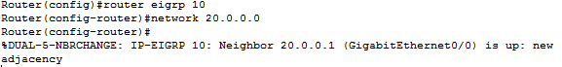

✓

EIGRP is now running on all 3 routers!

✓

1. Run the show ip neighbors command on R3

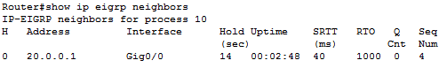

✓

1. Run the show ip neighbors command on R2 and you should see 2 neighbors

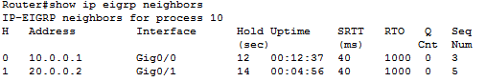

✓

1. Run the show ip neighbors command on R1

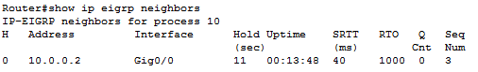

✓

1. Run the show ip route on R3  
     
   You should see a summarized route for the 3 (1.1 subnets of R1.)  
     
    **By default EIGRP does auto summarization**

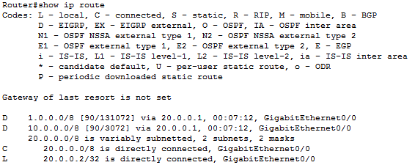

✓

1. If you want to have clear subnets (show each of the three separate subnets) then on R1, we issue the no summary command as it owns the 1.1 subnets.

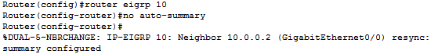

✓

1. Now go back to R3 and re-run the show IP route command and you will now see the three separate subnets.

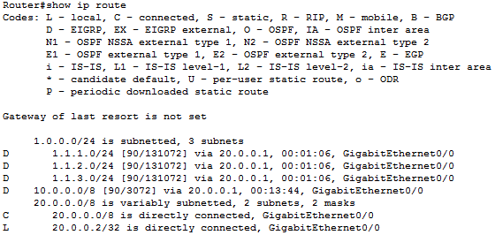

1. Run the show ip command on R2 and should see the 3 separate 1.1 subnets.  
     
    Insert a screenshot below of the show ip command with the 3 separate route

1. If you think about it. You do not need R3 learning about all the separate subnets as R3 is not a frequent user of the 1.1 network. This will allow us an opportunity to reduce the size of the routing table  
     
   Run the show ip route summary command on R3 and look at the size of the route table.  
     
   R2 should know about the 1.1 subnets but not R3!

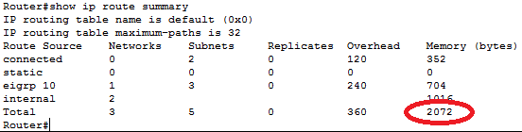

✓

1. We will do manual summarization on R2 on the G0/1 interface

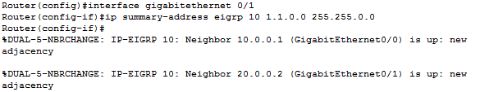

✓

1. Now run the show ip route on R3 and now we just have 1 route.

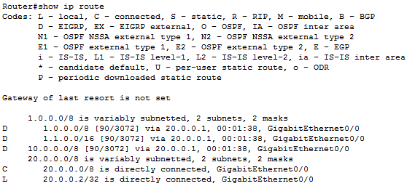

✓

1. From R3, attempt to ping 1.1.2.1…it should work  
     
    Insert a screenshot of your successful ping here!

1. Now check the size of R3 route table again and it should be a smaller size.





